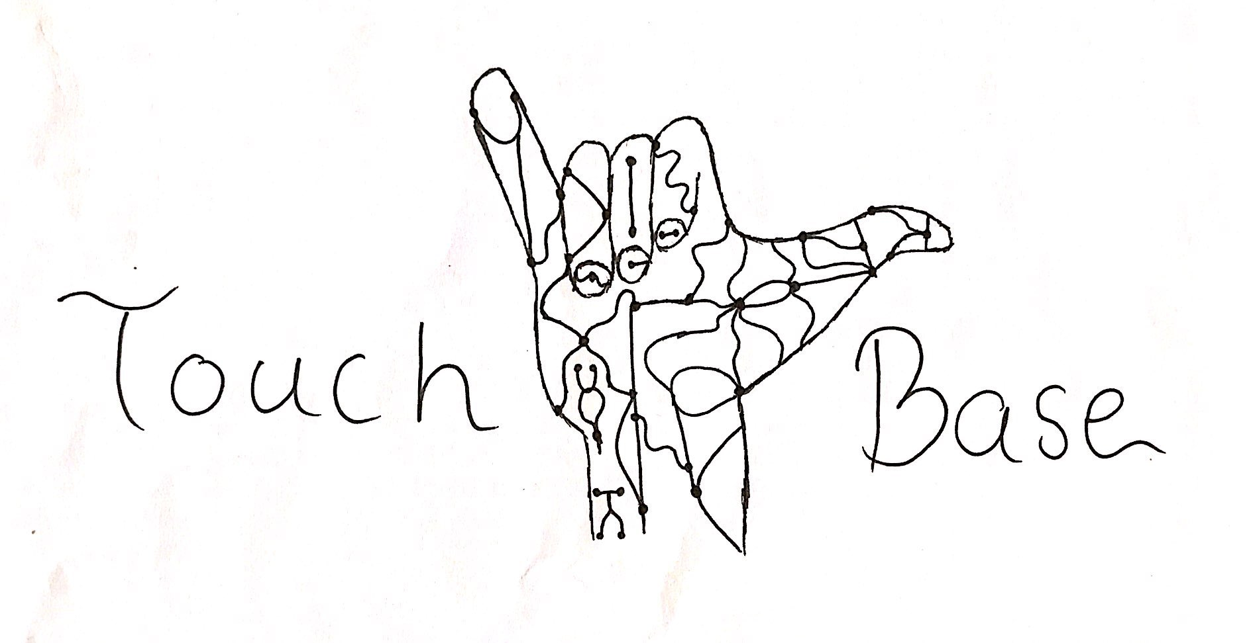
An Active Prosthetic Device
To: Dr. Kyle Winfree
From: Touch Base:
Aseel Yousef, Lihua Diao, Xiaohan Liu, Ethan Gage
Date: 11/09/2018
Re: Brainstorming and Mind Mapping
Mind-map:
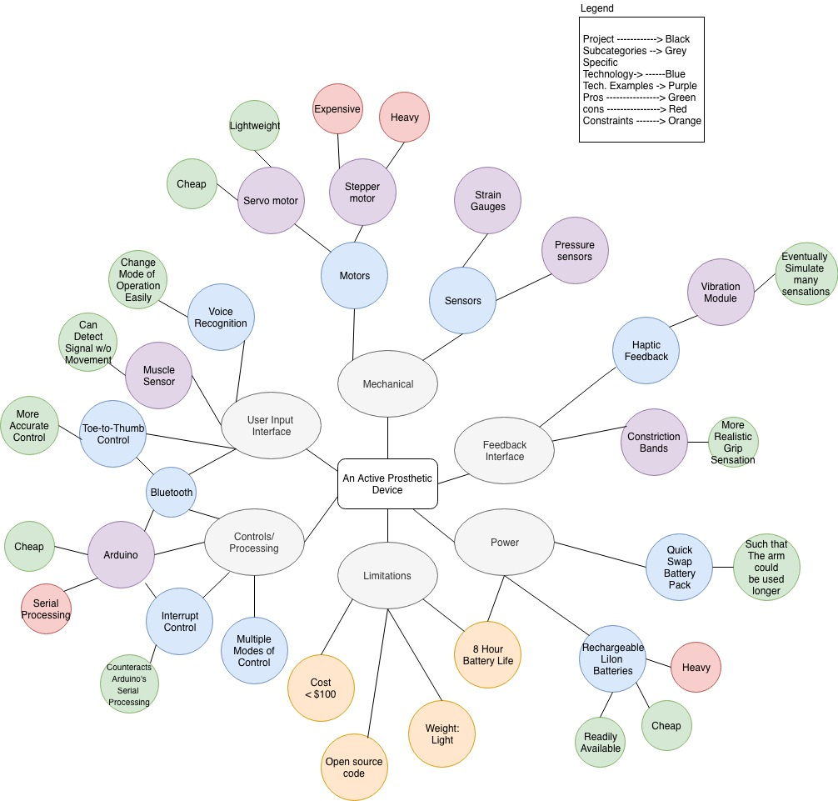
Figure 1. Mind-Map
Scope of Work:
Our team is working on designing and building the electrical components of a powered prosthetic arm for children in Northern Arizona with below the elbow amputation. The focus of the project is not just the working arm, but an interface that allows the user of the device to feel some touch-like sensation through the device. To accomplish this, we divided the project into general subcategories through project decomposition. We need some type of input interface to sense what the user is trying to do, we then need some computer processing to handle translating those user input into commands to be sent to the next category. To make the device act like an arm we need motors to act out those movements, being controlled by the previous computer processor. To be able to add a feeling of touch to the device, it first needs sensors to be able to detect various touch-inputs, those are then translated through the computer processor, and sent to some system that would simulate those same sensations to the user in an understandable way. Ultimately none of this can work without some kind of power system involved, so we need a way to store power on the device, and be able to charge that power or replace it to keep the device running as long as it possibly can.
User-interface:
After the group discussion, we have several user input interface. They are voice recognition, muscle sensor, and toe-to-thumb control.
Voice recognition is a very intelligent method to control the operation. The voice sensor could catch the sound and transmit it to voice recognition card. The voice recognition card processes the sound signal and passes the processed signal to the control system. This method requires a database of voice action commands to compare with the detected voice. Because this method needs some devices such as voice sensor and microprocessor, the volume has become a challenge. Also, the operational flexibility would be influenced by the sound, processor speed or other factors. How to improve the anti-interference ability of prosthetic control system to the outside is a problem that needs to be solved in voice control prosthesis.
For muscle sensor, it evaluates and records the electricity activity produced by skeletal muscles, and is also called electromyography (EMG) sensor. EMG is divided into surface EMG and intramuscular EMG which inverts needle electrode into muscle. In this project, we use surface EMG. Surface EMG requires more than one electrode because EMG records show the voltage difference between the two independent electrodes. Because the original EMG signal has positive and negative components, we need to carry out full-wave rectification of EMG signal. Because of individual differences, muscle fatigue, electrode position and other reasons, the change of EMG signal characteristics will reduce the accuracy of EMG prosthesis control. However, its related research is more careful and advanced, and can achieve the autonomous control of prosthetic system in a physiological way. It is an ideal signal control source for prosthetic.
For toe-to-thumb control, it uses the Bluetooth at foot to enable pressure sensors to transmit signals. The pressure sensor is fitted into the user’s shoes, designed to sit underneath the toes. The thumb is connected by Bluetooth technology, and the sensor activates motors in the prosthesis to move in different directions. However, the location of Bluetooth is a limitation. Some kinds of shoes may not be suitable for installing Bluetooth.
Controls and Processing:
To start we are deciding to use an arduino microprocessor, as they are a cheap way to design electro-mechanical systems, of which we all have some experience with. The arduino platform itself is open source, so it would be easy for people around the world to use our data files for an arm of their own. With the arduino, motors are very easy to control, and there are many resources out there we can use to build our program. The arduino is also compatible with the other types of user interface, and connectivity we plan to use, bluetooth, voice recognition, etc. We all have some experience with the arduino, so we can start working on the project immediately. The arduino platform is based on serial processing, where it can only process one line of code at a time, usually. Because of this, complex motor control systems need to implement a interrupt based control, allowing more accurate multi motor control.
Mechanical:
We need motors to act out children’s movements. Because this motor is mounted on the child’s arm, and children cannot handle heavy weighted devices, which makes them feel tired, it should be light. Besides, our goal is to make a cheaper arm that every family can afford. We decided to use servo motors, instead of stepper. Servo motors are self-contained electric devices that rotate or push parts of a machine with great precision. It consists of a suitable motor coupled to a sensor for position feedback. A positional sensor on the final gear is connected to a small circuit board. The sensor tells the circuit board how far the servo output shaft has rotated. The electronic input signal from the computer or radio also feeds into that circuit board. The electronics on the circuit board decode the signals to determine how far the user wants the servo to rotate. It then compares the desired position to the actual position and decides which direction to rotate the shaft so it gets to the desired position. To control the servo motor, we need to send a series of pulses from the computer or radio to it. A pulse is a transition from low voltage to high voltage which stays high for a short time and then returns to low. In battery devices such as servos, “low” is considered to be ground or 0 volts and “high” is the battery voltage. Arduino ™ have software commands in the language for generating these pulse trains. The servo must be connected to a source of power (4.5 to 6 volts). The pulse train is about 50 to 60 Hz, and the pulse width will vary from approximately 1 millisecond to 2 or 3 milliseconds.
We will add strain gauge on the finger to judge how much press will happen when children hold something with their hand. A strain gauge is a sensor whose resistance varies with applied force; It converts force, pressure, tension, weight, etc., into a change in electrical resistance which can then be measured. Then we will translate it into a kind of signal to tell our users how much power he used.
We plan to put the pressure sensor under the toes to detect the user’s requirements. A pressure sensor is an instrument consisting of a pressure sensitive element to determine the actual pressure applied to the sensor and some components to convert this information into an output signal. When the user presses down with one foot, the signal will be transmitted to the servo motor via Bluetooth, and then the servo motor controls the finger to make a grasping movement.
Feedback Interface:
To allow some kind of touch sense in the arm, we intend to employ one of multiple techniques. One being haptic feedback, where there is a vibration module at one or multiple points on the arm, that would vibrate with various patterns to mean various sensations. Another technology we are thinking of implementing is some kind of constriction device on the human side of the arm. In theory, the constriction device would have a band encircling the client’s arm that would constrict, or tighten around the client’s arm proportional to how much a motor has moved, or how much power a motor is exerting. Potential issues with these technologies are the control algorithms, and the human interface, we can spend days programming simple sensation responses, only to test them and have the client either not like them, or be unable to properly utilize the functions. Specifically, we have researched a paper regarding the simulation of the sensation of an object slipping through one's grasp, the technology involved is a specific set of vibrations from a haptic feedback device. Though we can program the device to operate on those specific parameters, we won't know if it actually works until we can let the user try it.
Power:
There are many parts that need power supply to keep the device active, such as: the arduino and the motors. We would want to use light, and cheap power supplies that last for at least 8 hours. We can use a rechargeable Lithium ion battery since it is cheap, readily available, and lasts for a long periods of time. The life time of the Lithium ion battery can last up to 2 - 3 years, however the battery will slowly decrease its capacity and that will result in the decrease of its power, it also can result in a fire hazard, where the battery can explode that is resulted in short circuit and when releasing its stored power all at once. Therefore, another solution would be, using a quick swap battery pack, they are cheap and lightweight. Using the quick swap battery pack would result in avoiding the need to wait for the device to fully recharge and the device could last twice as long as the rechargeable batteries. We are going to balance the usage of the power supplies in both powering the Arduino and the motors in terms of power capacity and the weight of the batteries. The heavier power supply will be powering the motors, and the Arduino will be powered by a lighter power source to keep the balance. When discussing the assembly of the device with the client, he pointed out that he would prefer the device to be lighter on the lateral end, where the Arduino would be installed, rather than having it lighter on the proximal end, where the motors would installed, making it easier and faster for the prosthetic arm to be lifted up and down.
Challenges:
One main challenge is going to be keeping the price of the arm under $100, luckily with 3D printing technologies we can greatly decrease the cost of the some of the mechanical components. But we will still need to purchase the logic device, sensors, batteries motors, and transmission for the motors, wires, pulleys, gears, etc. Another challenge is going to be deriving all the programming algorithms to control the device, to have the device mimic lifelike movement, and to give sense feedback to the user are going to require many hours of programming. As mentioned previously, the Arduino platform that we plan to use is a serial processing unit, so we cannot simply control the device with the simplest motor control algorithms available. We need to utilize interrupt programming, which we will have to climb a learning curve to be able to use.
One of our requirements being the device needs to have an 8 hour battery life, we will need to have a large battery pack to power the device. We are also trying to keep the weight down, so we will need to find a balance between weight and power capacity of the batteries we choose. We may decide to use multiple power sources to power the logic, and the motors separately. If we do, we can decrease the weight by having a very light weight logic power, and a smaller, heavier weighted pack for the motors than if we used the same pack for both motors, and logic.
Requirements and Constraints:
- Hardware/ software customizable: the prosthetic device should be customized according to the children’s arm sizes, and the user should be able to further customize software operations.
- A battery life that lasts at least for 8 hours: Children spend a long time engaging in different activities including outdoor activities and video games, thus it is important to have the active prosthetic device functional for at least 8 hours.
- electromechanically controlled: The prosthetic device needs to be able to convert electrical energy to mechanical energy.
- Open source code: All design files should be downloadable for future users.
- Cheap and lightweight hardware components: The device should be cheap and light enough to use in different activities on a daily basis.
Closing:
To accomplish our goal in designing the most convenient active prosthetic device, every aspect of the project will be tested thoroughly. We will be working on prototypes before we finalize the device.
Thank you for choosing us to work on this project, we will do our best to reach this project’s goal.

